THE NATIONAL REGIONAL GOVERNMENT OF OROMIA
OROMIA ENVIRONMENT, FOREST AND CLIMATE CHNAGE AUTHORITY CENTRAL AND EASTERN OROMIA OFLP CLUSTER

Oromia National Regional State Forested Landscape Program (OFLP)

Title of the Training: Safeguard Management and Implementation Training
for Development Agents (DAs) Lume Woreda

By: Getachew Yigezu
Lume Cluster REDD+ Coordinator

November, 2018
Lume, East Shewa

Training Title | Safeguard Management and Implementation Training for Development Agents (DAs) Lume Woreda
Brief overview | Overview of OFLP Safeguard management  OFLP Environmental and social safeguards management has been categorized as category B by the World Bank classification. Because the program will not cause adverse impact and will not finance any activity which cause adverse impact on environment and social impact. If the impact to be site specific and localized at small and medium scale will be mitigated through good design appropriate mitigation.  Environment and Social Safeguards Management  The OFLP will comply with applicable Ethiopian environmental and social legislations/policies and the World Bank Safeguard Policies. The Program will not finance any activity which causes significant adverse environmental and social impacts. The potential impacts, if any, are expected to be site-specific, and localized at small to medium magnitudes and mitigable through good design and appropriate mitigation measures. Therefore, the OFLP has been categorized as Category B by the World Bank classification.  OFLP triggered eight out of ten World Bank's safeguard operational policies  Social Safeguards Management  The OFLP will operate in a changing and fragile environment with complex social relationships and will likely face social concerns related to the existence of underserved peoples and vulnerable groups in its intervention areas. The social development challenges facing forest-dependent communities include inadequate understanding of relevant social issues; weak capacity and expertise within the government structures to address proposed mitigation measures to risks; weak land tenure at the individual and community levels, particularly among forest-dependent communities; and inequality in sharing benefits from natural resources.  The OFLP social safeguards therefore seek to ensure the full and effective participation of local community, underserved/vulnerable people, forest dependent communities, women and other relevant stakeholders in the program, and guarantee their timely access to appropriate and accurate information.
Training Objective/s are: | - To capacitate the relevant OFLP DAs on how to establish, operationalize, and strength OFLP safeguard management (for managing safeguard in Lume Cluster Lume Woreda OFLP carbon accounting area) according to World Bank safeguard standard.  - To aware Development Agents (at Kebele level) of relevant implementing sectors of OFLP on the concept of REDD+, Oromia forested landscape program, OFLP safeguard management and instruments.
Training Process/Methods | The trainee/Development Agents (DAs) at each Kebeles and technical committee at each Woredas were informed to attend the training on the concept of “safeguard management and implementation as well as overview of REDD+ project” for two days through their Woreda Agriculture and Natural Resources Management Office on their hosting Woredas to gain a capacity on the concept of REDD+ project and Safeguard Management issues. Woreda deputy chair person or head of Woreda Agriculture and Natural Resources Management office, head and of WoEFCCA and Technical committee were also informed through WoEFCCA and Lume Cluster OFLP Woreda Coordinator to get capacitated on overview of REDD+ and Safeguard management. Then Woreda coordinator was responsible in delivering the training for the participants. During the training the following contents have been actively discussed with the participants.  - Definition of Safeguard,  - Why Safeguard is needed in OFLP,  - REDD+ Safeguards,  - Aims and principles of REDD+ Safeguards,  - World Bank Safeguard Policies,  - Deforestation and Forest Degradation in Oromia and Proposed Strategic Option,  - OFLP Interventions Vs Environmental and Social Benefits/Risks and  - OFLP Safeguard Instruments.  During the training the participants have actively participated and a number of constructive suggestions, questions and answers were forwarded by all stakeholders.
Date | 29-30/05/2018
Location(where the trainee come from) | East Shewa
Location(where the trainee come from) | Lume Woreda
Location(where the trainee come from) | 35 Kebeles
Responsible body | Training institution (WoEFCCA/Lume Cluster Woreda Coordinator
Responsible body | Woreda Coordinator/Getachew Yigezu
Number of Participants | Female participants = 8
Number of Participants | Male participants = 35
Training costs | 43*420 = 18,060.00ETB (DAs and Technical Committee)  2*420 = 840.00ETB (Accountant, cashier and driver)  Total DSA = 18,900.00ETB
Results/output | - Expanded forest area under sustainable forest management by capacitated community groups  - Increased practice of sustainable management of forests and forest landscapes to address the drivers of deforestation and forest degradation  - Empowered forest-dependent villages and households of various ethnic groups practicing sustainable livelihoods  - Strengthened the governance, incentives and REDD+ framework  - Insuring increased number of households with monetary and non-monetary benefits from forest
Result Contribution | The outcome of the safeguard training will be the implementation of the OFLP at each kebeles of Lume Woreda as stated in the project implementation manual. The implementing sectors of OFLP will get coordinated on the concept of REDD+, Oromia forested landscape program, OFLP safeguard management and instruments, climate change and CRGE, forest management, and other relevant sectoral activities complimenting the implementation of OFLP activities. Hence, forest cover will increase in Lume cluster OFLP program of Lume Woreda.
Conclusion and Recommendation | Conclusion:  In general, in the safeguard management and implementation training given to Lume Cluster Lume woreda a total of 35 Development Agents from Agriculture and natural resources management office, 6 focal persons from six stakeholders, 1 head of woreda Agriculture and natural resources management office, and 1 head of WoEFCCA, and two individuals (accountant and cashier) from Lume woreda as a support in paying the DSA have taken the training (totally 45 individuals were participated in the training).  The total training cost for safeguard management and implementation amounts eighteen thousand, nine hundred Ethiopian Birr (18,900.00 ETB).  Recommendation  Based on the challenges listed above the following are better to be considered by ORCU (Oromia REDD+ Coordination Unit) and National Regional State of Oromia Environment, Forest and Climate Change Authority.  These are:  - It is better if ORCU in collaboration with National Regional State of Oromia Environment, Forest and Climate Change Authority develop parallel projects which will work on the livelihood of those camel owners in order to protect the seedlings and avoid the invasive species in the mentioned woredas.  - ORCU should allocate budget for training on safeguards management to reach all Lume cluster OFLP program.
Photo | affix two to three representative photos of the training/consultation
list of participant | affix scanned copies of lists of participants if not links that is made online

Affixed three representative photos of the training
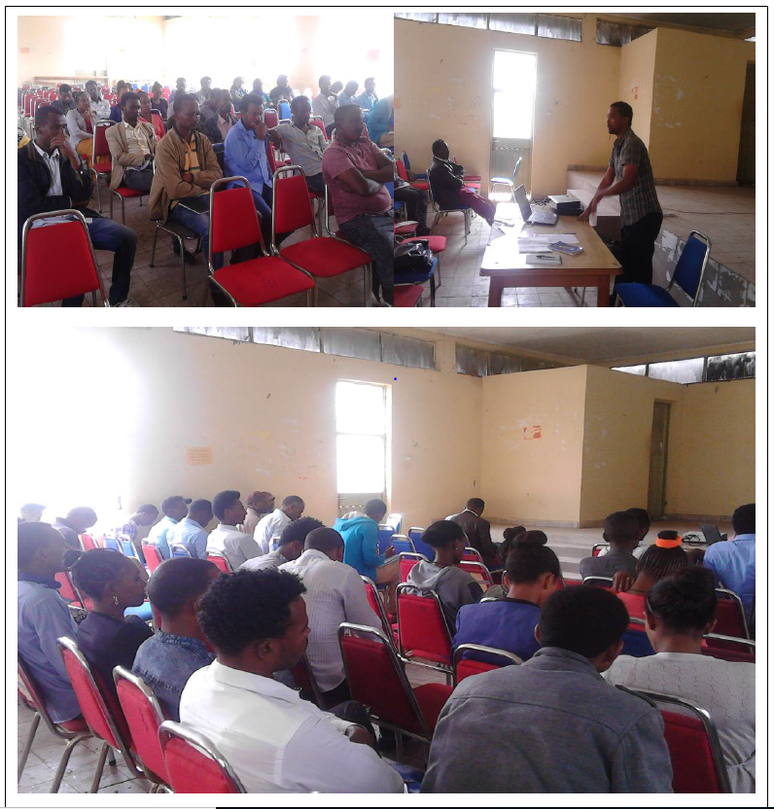

Affixed List of participants on safeguard management and implementation at Lume Woreda